Darmstadt, Feb. 13, 2020

Press contact:

Laura Tils
Brand Manager
Market & Brands
Acrylic Products

Riedbahnstraße 70
64331 Weiterstadt
Germany
T +49 6151 8501-2271
laura.tils@roehm.com

Thomas Kern
Global Communications BU Molding Compounds

Kirschenallee
64293 Darmstadt
Germany

T +49 6151 18-3071
F +49 6151 18-843071
M +49 152 09392226 thomas.kern@roehm.com

PLEXIGLAS® reveals new brand logo following recent establishment of Röhm GmbH

- Confident logo expresses brand strength
- Transparency, longevity, stability: new logo embodies brand essence
- First presentation with new brand logo at EuroShop in Düsseldorf

With an innovative redesign of its logo, PLEXIGLAS® continues to demonstrate its modern presence and adaptability 87 years after its trademark registration. The new brand logo of the inspiring acrylic glass brand, which was invented in 1933 by chemist Dr. Otto Röhm and his team in Darmstadt, integrates seamlessly into the corporate design of the newly established Röhm GmbH. The new Röhm was formed in August 2019 when Evonik Industries spun off its Methacrylate Verbund and CyPlus GmbH.

Like Röhm’s corporate brand, the PLEXIGLAS® logo is characterized by its linear, confident look. The fracture in the letters X and A symbolize transparency, lightness, brilliance and formability. The new logo concentrates on the essentials, fully in line with the company’s branding. The tagline “The Original by Röhm” rounds off the logo with recognition of the product's inventor. At the same time, the design of the brand logo takes up Röhm's tagline "Traditionally Innovative": It is an expression of tradition and experience by using a classic font, while at the same time illustrating an innovative and futuristic approach through sharp lines and fractures. The black and white design is not only linked to the design of Röhm´s corporate brand, but also to the "Black & Bright" communication campaign, which has been awarded the German Brand Award as well as the German Design Award .

The logo applies to the entire product portfolio sold under the PLEXIGLAS® trademark. This includes molding compounds and semi-finished products such as sheets, rods, tubes and blocks as well as films and in various specifications.

PLEXIGLAS® as a reliable material and innovation driver

PLEXIGLAS® is a versatile plastic and offering considerable design freedom to frabricators. It is especially UV- and weather-resistant, easy to process and is colored as required. Its light weight and excellent light transmittanceimpress in diverse areas.These include applications in the fields of the aviation and automotive industries, building and architecture, shop-fitting and illuminated advertising as well as furniture and interior design, lighting and optical applications.

Visit us from February 16 - 20 at EuroShop 2020 (Hall 11/Booth C40) and see our product portfolio of PLEXIGLAS® semi-finished products for yourself.

You can also find exciting PLEXIGLAS® product stories and application examples at www.plexiglas.de/en and www.plexiglas-polymers.com.

[Picture]
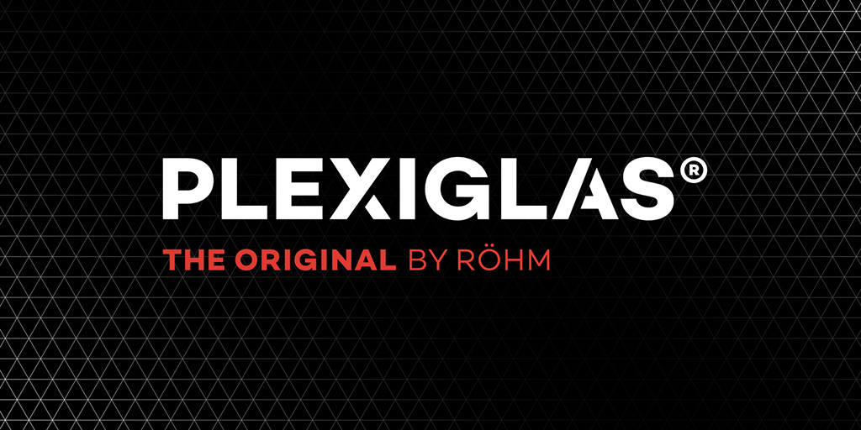
The new brand logo is characterized by its linear, confident look.

About Röhm
With 3,500 employees and 15 production sites worldwide, Röhm is one of the world’s leading manufacturers in the methacrylate business. The medium-sized company with branches in Germany, China, the USA, Russia, and South Africa has more than 80 years of experience in methacrylate chemistry and a strong technology platform. Our best-known brands include PLEXIGLAS®, ACRYLITE®, DEGALAN® and DEGAROUTE®. More information is available at www.roehm.com.

Disclaimer
Röhm GmbH and its affiliates are a worldwide manufacturer of PMMA products sold under the PLEXIGLAS® trademark on the European, Asian, African and Australian continents and under the ACRYLITE® trademark in the Americas.

